Practical Participation offer training & consultancy in using social media tools and strategies in participation projects.
This series of Getting Started guides are designed to offer a flavour of the tools available.

Version 0.1 – December 2007
Mapping your community
With Google Earth
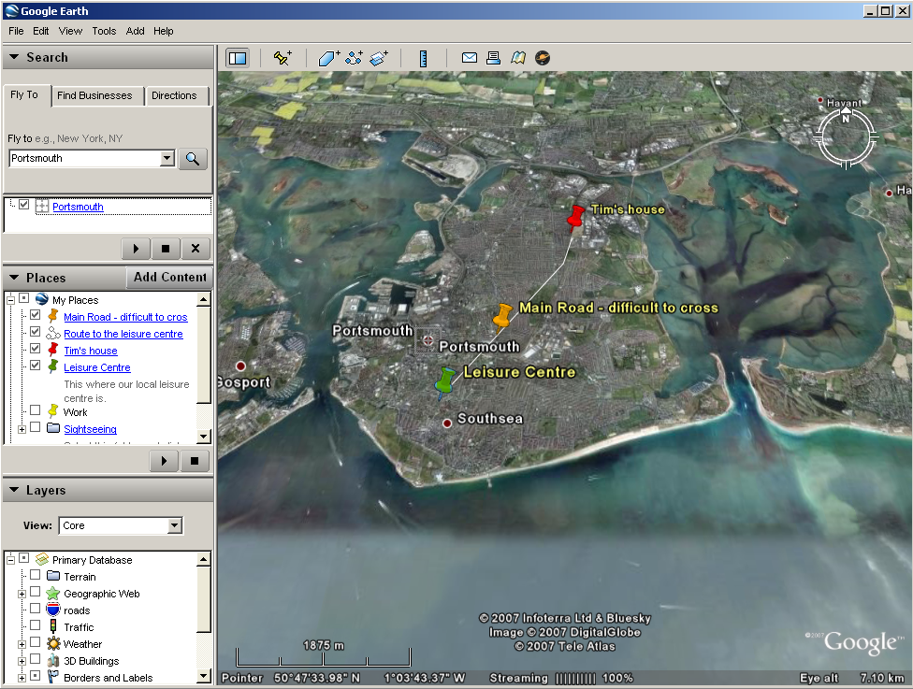
Google Earth allows you to view high resolution satellite images of your local area on a 3D globe.

You can add annotations and notes onto Google earth to record information about your area.

You can add lines and shapes to mark out particular areas on your map.

You can share your annotations so that they can be accessed on Google Maps (maps.google.co.uk) or in other mapping tools.

Getting Started

1) If you do not already have a copy of Google Earth you will need to download it from http://earth.google.com.

2) Open Google Earth and use the ‘fly to’ option to search for and zoom in to your local area.

3) You can change the zoom, rotation and viewing angle using the controls that appear in the top-right of the screen.

4) In the places window in the side-bar ‘right-click’ on ‘My Places’ and select ‘New Folder’ to create a folder to keep your annotations in.

5) ‘Right-click’ on the folder you have just created and select ‘Add -> Placemark’ to add a note/annotation to the map. You can give your placemark a title and a description, and clicking the drawing pin icon lets you select a new image.

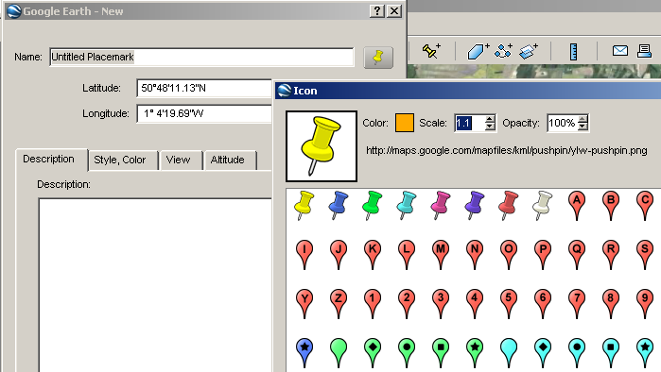

6) You can also add a ‘Path’ or ‘Polygon’.

Sharing your map

You can save your map as a KML file for other users of Google Earth by selecting ‘Save As...’ when you right-click on the folder you created.

You can also share your maps using the ‘Share/Post’ option from the File Menu.

